Topic Planning Worksheet

Category = black bold headings, not clickable by customers; an organizing feature for topics (Trending Topics, Departments)

Topic = the buttons that open a form for a customer to submit their question, comment, suggestion, compliment or concern through (Superintendent Search, Inclement Weather, Transportation Requests, Facilities, Food and Nutrition Services)

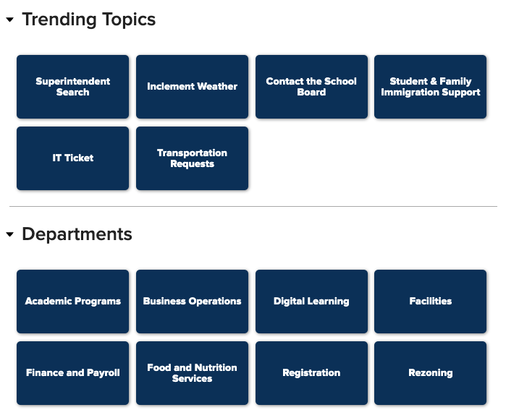

Topic Owner = someone who knows the topic well, will respond to or manage the majority of submissions that come to this topic, but does have the ability to change ownership over individual submissions as needed

Team Member = someone who will support the team owner in responding to messages that come in through Onflo (can be multiple people), can also view all submissions to this topic.

Step 1: Plan your categories and topics.

Category 1: <enter heading here> (Example: Departments or Trending Topics)

Topic(s) | Topic Owner (Can only be one person) | Team Members (Can be multiple people)
Employment Verification | Toby Flenderson | Michael Scott, Jim Halpert, Dwight Schrute

Category 2: <enter heading here>

Topic(s) | Topic Owner | Team Members

Category 3: <enter heading here>

Topic(s) | Topic Owner | Team Members

Category 4: <enter heading here>

Topic(s) | Topic Owner | Team Members

Category 5: <enter heading here>

Topic(s) | Topic Owner | Team Members

